DSA 0601 - Data handling and visualization
Set 18 - Product Inventory Management

Name : B.Jahnavi
Reg.no:192325043

- Bar Chart of Product Quantities
Code:

library(ggplot2)

inventory <- data.frame(
Product_ID = c(1, 2, 3),
Product_Name = c("Product A", "Product B", "Product C"),
Quantity = c(250, 175, 300),
Price = c(20, 15, 18)
)

ggplot(inventory, aes(x = Product_Name, y = Quantity)) +
geom_bar(stat = "identity") +
geom_text(aes(label = Quantity), vjust = -0.5) +
labs(
title = "Quantity Available by Product",
x = "Product Name",
y = "Quantity Available"
) +
theme_minimal()

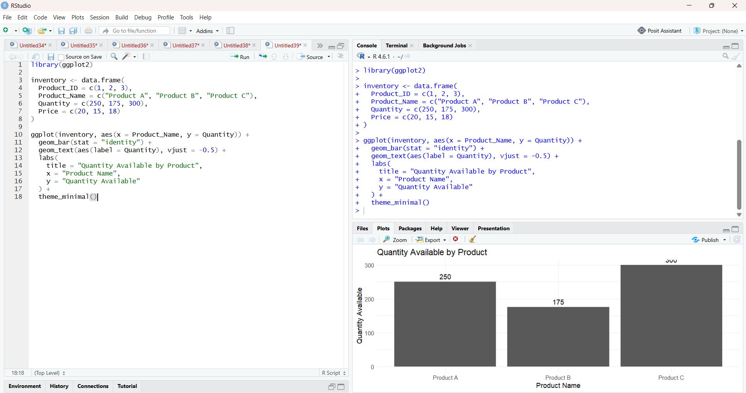

2. Stacked Bar Chart by Product Category
Code:

library(ggplot2)

inventory <- data.frame(
Product_ID = c(1, 2, 3),
Product_Name = c("Product A", "Product B", "Product C"),
Category = c("Electronics", "Clothing", "Electronics"),
Quantity = c(250, 175, 300),
Price = c(20, 15, 18)
)

ggplot(inventory, aes(
x = "Inventory",
y = Quantity,
fill = Category
)) +
geom_bar(stat = "identity") +
labs(
title = "Inventory Quantity by Product Category",
x = "Inventory",
y = "Quantity Available",
fill = "Product Category"
) +
Theme_minimal()

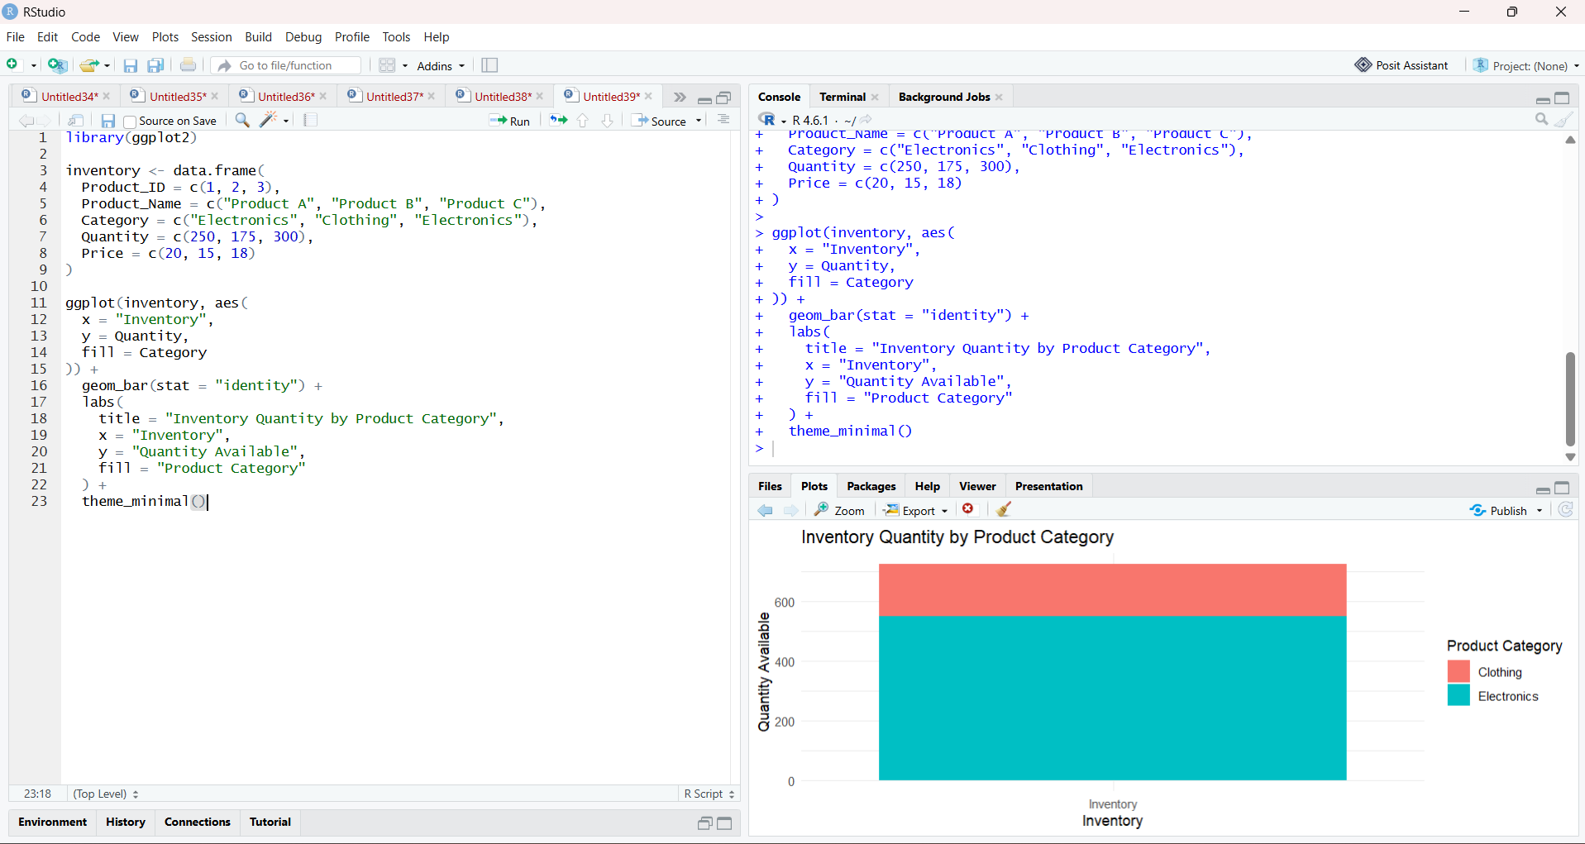

3. Table of Product Inventory
Code:

inventory <- data.frame(
Product_ID = c(1, 2, 3),
Product_Name = c("Product A", "Product B", "Product C"),
Quantity = c(250, 175, 300),
Price = c(20, 15, 18)
)

print(inventory)

library(knitr)

kable(
inventory,
caption = "Product Inventory Data",
col.names = c(
"Product ID",
"Product Name",
"Quantity Available",
"Price ($)"
)
)

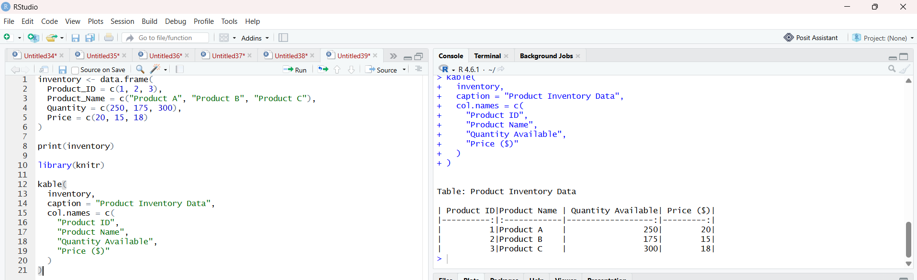

4. Prepare Data for Tableau Dashboard
Code:

inventory <- data.frame(
Product_ID = c(1, 2, 3),
Product_Name = c("Product A", "Product B", "Product C"),
Quantity = c(250, 175, 300),
Price = c(20, 15, 18)
)

write.csv(inventory, "product_inventory.csv", row.names = FALSE)

print("CSV file created successfully.")

